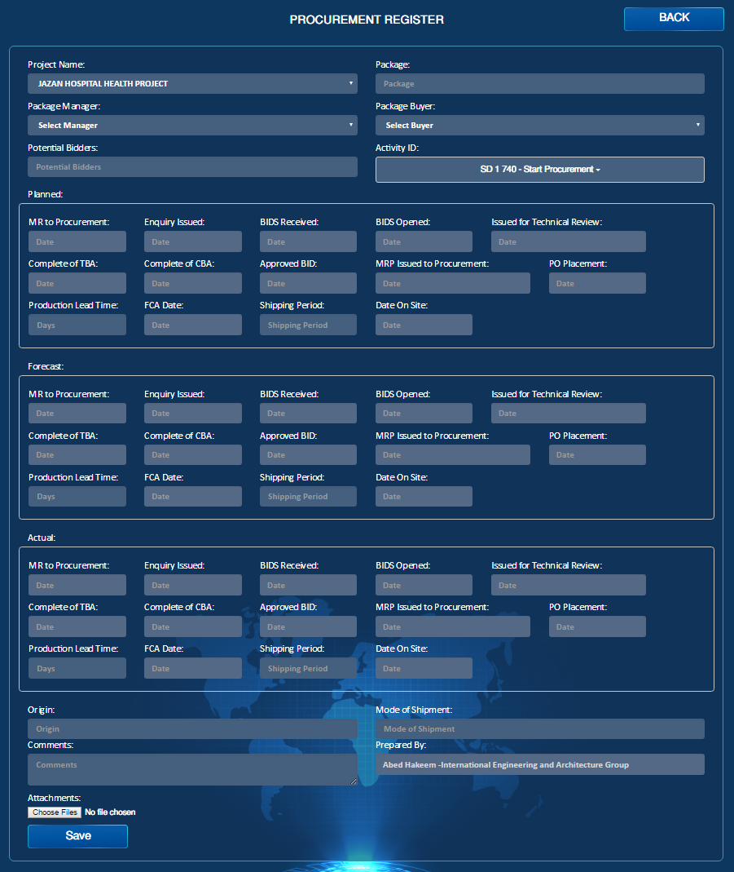

Pop UP

Pop UP

Add to Vendor Register

PO #

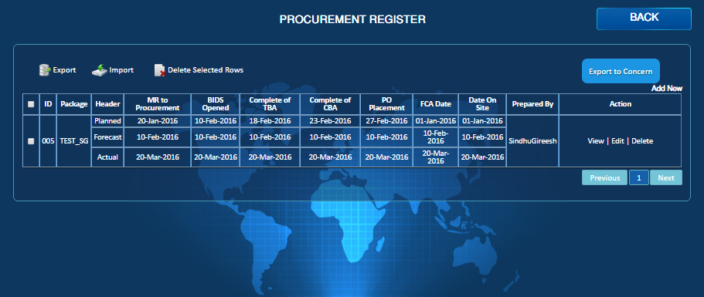

Transmittal

Show Links

Email

PDF

Data Date

**Procurement Register**

1. Activity ID should be considered in the Planned Pane as following:
2. ENQUIRY ISSUED ID.
3. BIDS RECIEVED ID.
4. BIDS OPENED ID.
5. ISSUED FOR TECHNICAL REVIEW ID.
6. COMPL' OF TBA ID.
7. PO PLACEMENT ID.
8. IF PO date is actual then the PO# Field will be active
9. After adding the PO # then add to vendor Register will be active
10. When you click on Vendor Register, then you will go to vendor Register Form (PO Number and description will be filled out Automatically as mentioned in the Vendor Register workflow.
11. Potential Bidders Field - when you Click on it Browse to Supplier List (New form) and choose from there then Close
12. To Include data date field in the List Page.
13. Ability to Search by PO number and discription.
14. Ability to filter by Planned, Forecast and Actual.
15. Should have the attachments in all (View, Edit).
16. Show Links button should be there(Will be linked Engineering, Material, Vendor Register, SWI, RFI,NCR,Change Order, Transmittal letter and Payment Invoice.
17. Export to Concerns in the List Page.
18. Print & PDF should be there in the list Page.
19. Highlight the delayed Steps in the forecast Line.
20. Legend for the Critical activities to be optained ( if PO Placement ID <0 then the line Item in the LOG should have red Flag (Same format as milestones) othe wise it is green
21. Transmittal Letter to be added as an Option in the list Page
22. The order of the fields in the Workflow should be the same as the form.